**8 SCIENCE 2016**

### CHEMISTRY TEST ONE

Name: ____________________ Teacher (please circle): LAFFERTY/CERNY/NORGROVE/MILNER

Mark: /53 Percentage: %

**MARKING KEY**

**SECTION A: MULTIPLE CHOICE (30 marks)**

**Select the most correct answer for each question below.**

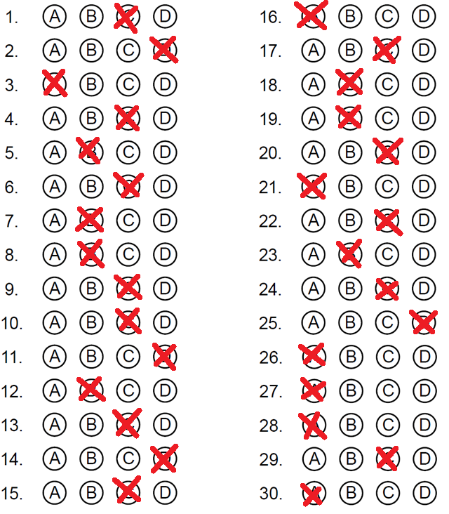

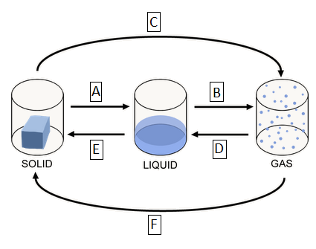**Question 1 to 6 refers to the diagram on the right.**

**1.** Label ‘A’ represents the process of:

(a) Evaporation.

(b) Condensation.

**(c) Melting.**

(d) Sublimation.

**2.** Label ‘D’ represents the process of:

(a) Freezing/solidification.

(b) Melting.

(c) Deposition.

**(d) Condensation.**

**3.** Label ‘F’ represents the process of:

**(a) Deposition.**

(b) Condensation.

(c) Freezing/solidification.

(d) Sublimation.

**4.** Label ‘C’ represents the process of:

(a) Evaporation.

(b) Deposition.

**(c) Sublimation.**

(d) Melting.

**5.** A puddle of water drying out would be an example of:

(a) The process represented by label ‘C’.

**(b) The process represented by label ‘B’.**

(c) The process represented by label ‘D’.

(d) The process represented by label ‘E’.

**6.** Water droplets forming on the bathroom mirror after a shower would be an example of:

(a) The process represented by label ‘B’.

(b) The process represented by label ‘F’.

**(c) The process represented by label ‘D’.**

(d) The process represented by label ‘C’.

**7.** Choose the correct missing words in this sentence.

When solids, liquids and gases are heated they expand and take up more space. The ________ of the object increases and the __________ of the object decreases.

(a) Space, density.

**(b) Volume, density.**

(c) The volume, space.

(d) Density, volume.

**8.** Choose the correct missing words in this sentence.

When solids, liquids or gases are cooled, they contract and take up less space. The volume of the object _________ and the density of the object __________.

(a) Spreads, increases.

**(b) Decreases, increases.**

(c) Decreases, cools.

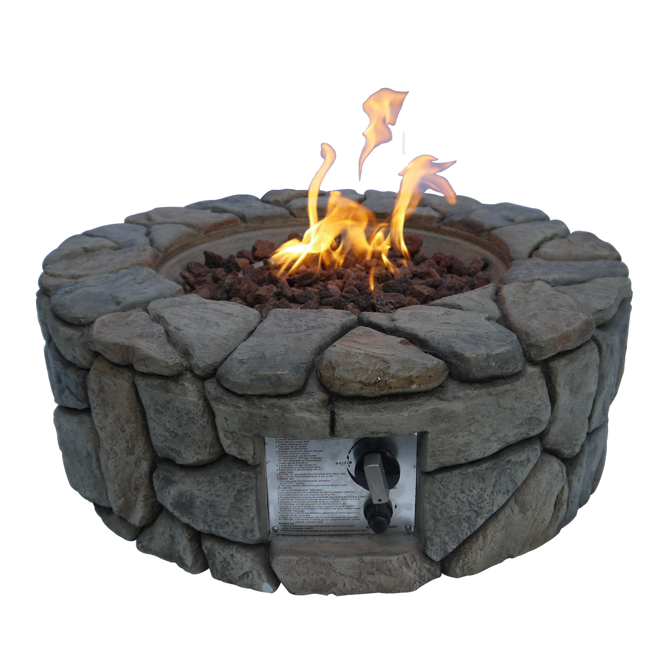 (d) Increases, decreases.

**9.** A burning fire is an example of:

(a) An external reaction.

(b) An endothermic reaction.

**(c) An exothermic reaction.**

(d) A internal reaction.

**10.** When a solute dissolves:

(a) Its particles are spread evenly through the solute.

(b) Its particles are spread unevenly through the solvent.

**(c) Its particles are spread evenly through the solvent.**

(d) Its particles are spread unevenly through the solute.

**11.** Perfume is sprayed at one end of the classroom and shortly after students at the other end of the room could smell the perfume. This is because a process occurred called:

(a) Contraction.

(b) Evaporation.

(c) Sublimation.

**(d) Diffusion.**

**12.** Choose the correct definition for ‘chemical change’.

(a) A change that results in reactants being produced.

**(b) A change that results in a new substance being formed.**

(c) A change that does not result in a new substance being formed.

(d) A change that does not result in reactants being produced.

**13.** A build up of lime on the showerhead is an example of:

(a) Deposition.

(b) Solidification.

**(c) A precipitate.**

(d) Condensation.

**14.** Mixing two substances together is a type of:

(a) Chemical reaction.

(b) Chemical change.

(c) Endothermic reaction.

**(d) Physical change.**

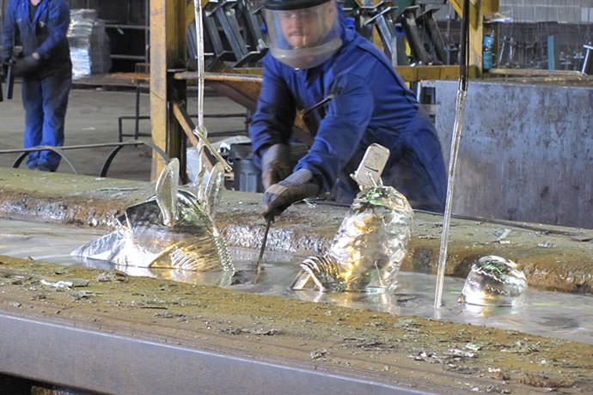

**15.** Dipping iron in a bath of molten zinc metal in order to prevent the iron from rusting is a process called:

(a) Coating.

(b) Alloying.

**(c) Galvanising.**

(d) Painting.

**16.** Corrosion is a:

**(a) Chemical reaction where a metal reacts with oxygen.**

(b) Physical reaction where a metal reacts with oxygen.

(c) Physical reaction where a non-metal reacts with oxygen.

(d) Chemical reaction where a non-metal reacts with oxygen.

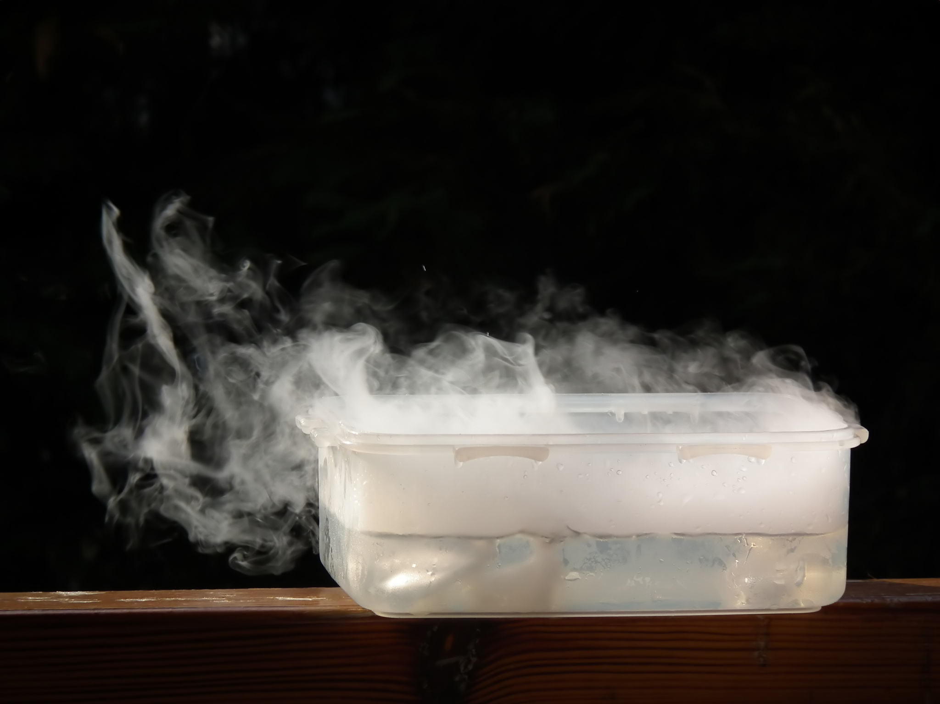**17.** Dry ice demonstrates an example of:

(a) Deposition.

(b) Boiling.

**(c) Sublimation.**

(d) Solidification

**18.** The simplest and cheapest way to protect iron from rusting is to cover iron with a material such as paint, plastic, or another metal such as chromium. This procedure is known as:

(a) Galvanising.

**(b) Coating.**

(c) Alloying.

(d) Plating.

**19.** Which of the following is **not** a type of physical change?

(a) Change in shape.

**(b) A gas is given off.**

(c) Expansion and contraction.

(d) Change of state.

**20.** Choose the correct definition for ‘sublimation’.

(a) A change of state from liquid to gas.

(b) A change of state from gas to solid.

**(c) A change of state from solid to gas.**

(d) A change of state from gas to liquid.

**21.** Choose the correct definition for ‘evaporation’.

**(a) A change of state where a liquid changes to a gas at the surface of the liquid.**

(b) A change of state from a solid to gas.

(c) A change of state where a liquid is heated and changes to a gas within the liquid

(d) A change of state where a gas is cooled and forms a liquid.

**22.** In which state of matter do the particles have the most energy?

(a) Solid.

(b) Liquid.

**(c) Gas.**

(d) Mixture.

**23.** In a solution, what term is given to the solid that has dissolved?

(a) Solvent.

**(b) Solute.**

(c) Mixture.

(d) Soluble.

**24.** In what ways are liquids different from solids?

(a) Liquid molecules are lighter than solid molecules.

(b) Liquids are made up of atoms; solids are made up of molecules.

**(c) Liquids don’t have a fixed shape; solids do.**

(d) Liquids are always denser than solids.

**25.** What happens to the chemical structure of water when it changes state?

(a) Water molecules break apart to form individual atoms.

(b) Water molecules harden into ice molecules.

(c) Water molecules melt into gas molecules.

**(d) Nothing happens to the chemical structure.**

**26.** What will happen if you keep increasing both the pressure and temperature of a liquid?

**(a) It will boil.**

(b) It will melt.

(c) It will solidify.

(d) It will condense.

**27.** The particle model assumes that all forms of matter are made up of invisible tiny ball-like particles that are:

**(a) Constantly moving.**

(b) Compressible.

(c) Divisible (able to be split).

(d) Able to be squashed.

**28.** 5 grams of salt is dissolved in 100 ml of water to form a salt water solution. The solution is heated and boiled away. How much salt would you expect to have left in the container?

**(a) 5 grams.**

(b) 95 grams.

(c) 2.5 grams.

(d) 100 grams.

**29.** The arrow in a chemical reaction means:

(a) ‘Gives the answer’.

(b) ‘Equates to’.

**(c) ‘Rearrange to form’.**

(d) ‘Equals’.

**30.** Select the correct statement referring to non-spontaneous reactions.

**(a) Reactions that need energy to be added constantly or it will stop reacting.**

(b) Reactions that proceed by themselves.

(c) Reactions that get enough energy from their surroundings to start and continue.

(d) Reactions that need a kick-start from an external energy source then produce enough energy to continue the reaction.

**SECTION B: SHORT ANSWER (23 marks)**

**1.** Explain the main difference between physical and chemical changes. (2 marks)

**Physical change does not result in a new substance being formed (1) whereas a chemical change does result in a new substance being formed (1).**

**2.** Label the products and the reactants for the chemical reaction below. (2 marks)

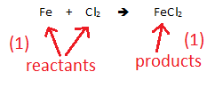

**3.** When sodium hydroxide (NaOH) is mixed with hydrochloric acid (HCl), a salt called sodium chloride (NaCl), and water (H2O) are produced.

a) Write the word equation for this reaction. (1 mark)

**Sodium hydroxide + hydrochloric acid ➔ sodium chloride + water**

b) Write the formula equation for this reaction. (1 mark)

**NaOH + HCl ➔ NaCl + H2O**

**4.** When iron oxide (FeO) is heated in the presence of carbon monoxide (CO), they combine to produce carbon dioxide (CO2) and pure iron metal (Fe).

a) Write the word equation for this reaction. (1 mark)

**Iron oxide + carbon monoxide ➔ carbon dioxide + iron**

b) Write the formula equation for this reaction. (1 mark)

**FeO + CO ➔ CO2 + Fe**

**5.** Atoms can be created and destroyed during a chemical reaction. (1 mark)

(Circle your answer) True or **false**

**6.** In the table below, write whether the processes are physical or chemical changes. (4 marks)

|  |  |
| --- | --- |
| **Process** | **Chemical change or physical change** |
| Crushing a can | **Physical change** |
| An egg rotting | **Chemical change** |
| Burning a match | **Chemical change** |
| Snapping a pencil in half | **Physical change** |

**7.** Fill in the table below, which relates to the particle model. (10 marks)

|  |  |  |  |
| --- | --- | --- | --- |
|  | **Solids** | **Liquids** | **Gases** |
| **Shape** | Hold their own shape. | **Flow to shape of**  **container.** | **Fills its container.** |
| **Incompressible**  **or compressible** | **Are incompressible**  **/ not able to be compressed** | Are incompressible. | **Compressible/ able to be**  **compressed** |
| **Strength of**  **bonds**  **between**  **particles** | **Strong** | **Weak** | None. |
| **Movement**  **of particles** | Vibrate on the spot. | **Vibrate and slide past each other.** | **Move fast in all directions.** |
| **Space between**  **particles** | **None.** | Almost none. | **Large.** |